People are not Computers
One of the big issues that makes working interacting with a computer difficult is the assumption that they are in some way like us.
There are two issues that impact significantly on how we might teach computing as educators and how users interact with technology…
- Mental models
- Cognitive load

Mental Models and Constructivism
A mental model may be thought of as a theory of how the world around us works.
When I was a child, I asked the family the following question…
“When you open the door at night why doesn’t the dark come in?”
Here is another one.
Once another child was asked (Papert, 1993) …
“what makes the wind blow?”
to which they replied,
“the leaves on the trees.”
Constructivism takes the view of that knowledge is “constructed” by the learner via their direct personal experience of reality, rather than “poured into their heads” via textbooks and lectures. Rather than starting with a “blank-slate” our view of external reality is filtered and coloured by several factors including our prior knowledge, expectations, emotions and prejudices. The internal beliefs and perceptions of the individual will inevitably have a direct impact on their behaviour. Constructivism takes the view that there is a knowable universe “out there” however our internal constructed version of it will inevitably fail to map.
This is never truer than in the process of interacting with a computer system.
There may be a tendency to “anthropomorphise” the computer system, that is treat it like it is a person. A novice programmer may write a section of code, expecting the computer to understand their intent. They wrongly imagine that the computer will “get” what they as a programmer mean by their efforts at writing code but fail to appreciate that the computer is simply a machine.

What Is The ‘Bug’ In This Sequence of Scratch Blocks?
Work through this sequence of blocks and think about the differences with your version of the Slug game?

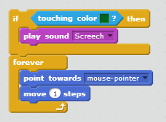
Another common misconception among novice programmers is the idea that a variable may store two values simultaneously. If a novice programmer believes this, then they might erroneously conclude that the output would be 3, 8 and 5 rather than the correct answer 8, 8 and 5. (The initial value of 3 assigned to A has been over-written by the new value of 8.)
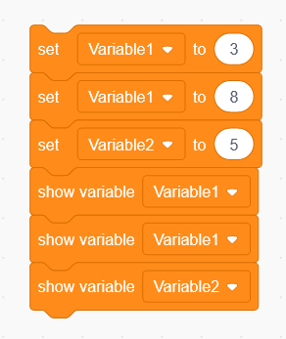
The questions therefore arise how are these mental models refined and developed and what can be done by educators to facilitate this process? There are many different theories of learning, however, there is insufficient scope to look at each of these in detail, but we shall provide a very brief introduction and concentrate on theories related to constructivism and ultimately Problem Based Learning.
In order to understand the world around us it is necessary to make assumptions relating to its nature, i.e. an ontology or world view. For this discussion we shall consider two such views, they are logical positivism and constructivism. As a world view, logical positivism takes the view that knowledge exists, “out there as objective truth”. In a logical positivist position, there is an objective reality to be understood and most significantly, personal subjective experience plays no part in understanding this reality.
Piaget (Piaget et al., 1956) devised the three-mountain task to examine learning in children. Children are shown a scale model of three mountain peaks and asked to describe the mountains from a different perspective. Piaget found that children between four and six could understand the question but were unable to do what was asked of them (Jarrett and Ginsburg, 2008).
Another concept driving learning in Piaget’s view is that of accommodation and adaptation. In this case learning and change come about when a person encounters an unexpected result.
“Why doesn’t the dark come in at night”
It is in fact the problems we encounter that provoke learning. Upon encountering a problem, we accommodate the unexpected outcome with new information (accommodation) and ultimately adjust by modifying our internal models (adaptation).
By interacting with the external environment sophisticated mental processes are developed. Vygotsky continues with the idea that learning occurs also via interaction with a skilled tutor or More Knowledgeable Other. For example, consider a parent helping a child with a jigsaw. The parent initially provides some basic strategies for attempting the puzzle, yet over time allows the child greater autonomy as they become more competent at the problem. In this example we see the parent taking the role of Vygotsky’s More Knowledgeable Other illustrating the kind of social interaction using cooperative and collaborative dialogue promoting cognitive development.
Another concept put forward by Vygotsky is the Zone of Proximal Development. Related to the concept of More Knowledgeable Other it relates to those tasks a child can complete without assistance compared to those tasks a child needs guidance and support.
This is true of all teaching, but it is especially true of teaching computer programming. It is essential to find that sweet spot of building on existing learning, providing just enough challenge coupled with the appropriate scaffolding from the tutor and the learning environment.
“The zone of proximal development defines functions that have not matured yet, but are in a process of maturing, that will mature tomorrow, that are currently in an embryonic state; these functions could be called the buds of development, the flowers of development, rather than the fruits of development, that is, what is only just maturing” (Vygotsky, 1978, p. 86).
So, what does this have to do with teaching and learning computer programming?
- It means that as you learn how to teach programming, you will need to work through your own misconceptions, personal reflection is important
- It means that you need to anticipate and identify these misconceptions in your learner’s thinking and support them in building more appropriate mental models
- It means that your learners need to be provided with activities that are appropriate to their level of existing knowledge

Mental Models and Constructionism

“When teaching the computing curriculum, look wherever you can for practical, creative projects that pupils can work on, perhaps individually, perhaps with a partner, or as part of a small group: this, after all, is how programming and information technology happens in the ‘real world’ and on most university courses. The projects you set are more likely to be motivating if they’re linked to your pupils’ own interests and enthusiasms. These might be to do with other curriculum areas, the life of the school, or their interests beyond school.
Also, look for an audience for pupils’ work, whether they’re presenting to one another, writing for a public blog, creating software or digital content for younger pupils, or planning to upload their work for others to see, via Scratch or a school YouTube account.”
Teaching Section From CAS Primary Guide

Cognitive Load
Miller, (1956) noted that working memory comes with certain limitations suggesting that it has a limited capacity of seven items plus or minus two. The theory assumes that human cognition comes in two forms, cognition associated with long term memory and that associated with short-term memory. Cognitive load theory recognises that problem solving may take a role in the learning process; however, it also asserts that relying solely on problem solving may not be the most efficient way of learning. Noting that there are limits on people’s ability to process data, the theory proposes that data enters working memory in “chunks”.
Cognitive load theory identifies three forms of cognitive load which need to be considered for a learner; intrinsic, extraneous and germane.
Intrinsic cognitive load is that required for learning a task. For example, if a student needs to understand how Scratch works, they must exert a fixed amount of effort in achieving this understanding.
Extraneous cognitive load is generated by the nature of the instructional design, for example a concept “this is Scratch” could be describe to a learner verbally or it might be more easily be demonstrated using a live demo.
Germaine cognitive load relates the internalisation of learned content, i.e. building the structures in long-term memory.
The idea in cognitive load theory is that instructional design should aim to reduce extraneous cognitive load allowing the student to focus on internalising the knowledge. In my experience students appear to want clarity in communication of concepts. Students want clarity of content and clarity from the tutor. Students identify barriers to learning such issues with out of date content and access limitations. Rather than explaining how code works, the students state a preference for direct observation of the code being constructed and used.

So What?
Let’s look at a pretty easy example of cognitive load using Zombie Island. Look at the following screen shot for level 1 of the game…
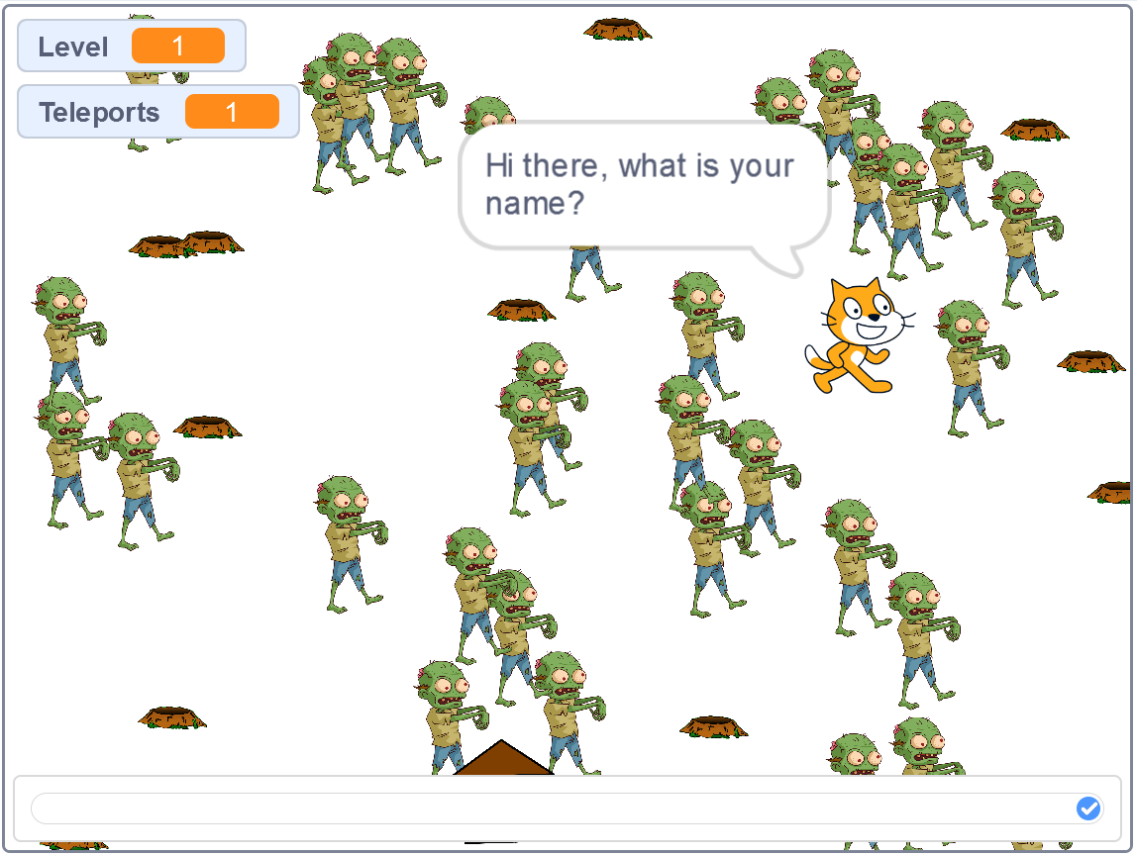
What is the problem?
Clearly there are a lot of zombies for the first level of the game.
Remember working memory comes with certain limitations suggesting that it has a limited capacity of seven items plus or minus two.
We can overload the user of the system by presenting them with too many things to deal with, or we can do it by asking them to concentrate on too many things at one called the split attention effect.
For example, we might set up the game with an instructional video showing the game running and provide text instructions that they have to follow in conjunction. Load music playing while they are expected to read instructions can produce a similar effect.

Recognition versus Recall
Let’s make a tiny change to the design of Zombie Island.
Note how Scratch provides instruction to the user at the start of the game…
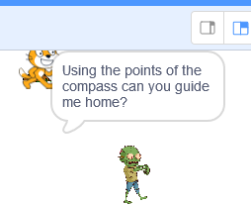
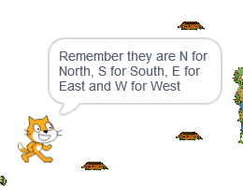
Note especially the final step…
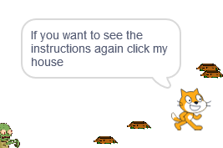
What happens if we remove that last step?
The user would be presented with the set of instructions…
And they would be expected to remember them for the rest of the game.
This places extra load on the brain as it has to remember what the instructions were.
It is better to allow the user to see the instructions again (clicking on the house is still not idea as they need to remember that)
It is even better to put a button somewhere that says “help” or “instructions” allowing the user to see the button and press it when needed.
Recognition means there is a constant visual prompt, recall forces the user to remember things, Recognition good recall bad.
You will have experienced this when asking for directions to somewhere and you don’t write them down.
After a few minutes you will have forgotten the instructions and will be lost once again, an experience you should try not to inflict on the users of your system.

References
Jarrett, C. and Ginsburg, J. (2008). This book has issues. London: Continuum.
Knuth, R. A. & Cunningham, D. J. (1993) Tools for constructivism. In Duffy, T. and Jonassen, D. (1993). Designing environments for constructive learning. Berlin: Springer.
Miller, G. (1956). The magical number seven, plus or minus two: some limits on our capacity for processing information. Psychological Review, 63(2), pp.81-97.
Paper, S. (1993) Mindstorms, Children Computers and Powerful Ideas. London: Harvester Wheatsheaf
Piaget, J., Inhelder, B., LANGDON, F. and LUNZER, J. (1956). [La Représentation de l'espace chez l'enfant.] The Child's Conception of Space ... Translated ... by F.J. Langdon & J.L. Lunzer. [With illustrations.]. Pp. xii. 490. Humanities Press: New York; Routledge & Kegan Paul: London; printed in Great Britain.
Vygotsky L. S. (1978) Mind and Society, Cambridge MA: Harvard University Press.

